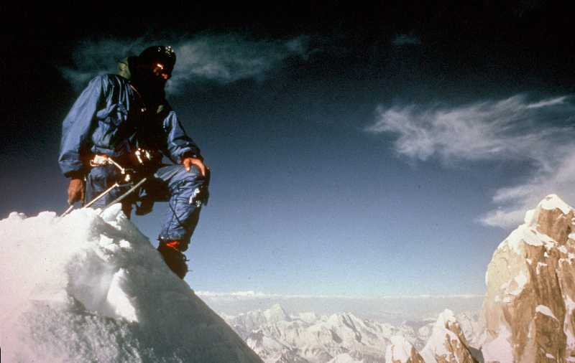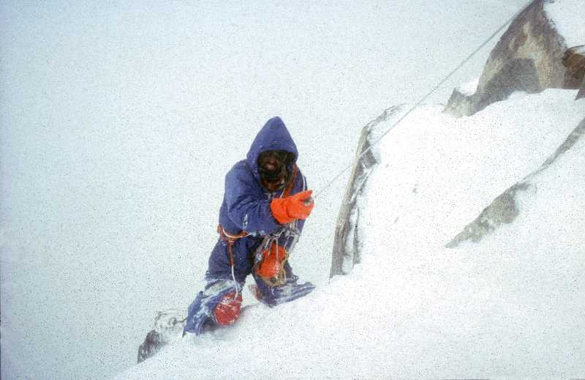

‘A Crawl down The Ogre’ talk by Doug Scott CBE
Tuesday 11th October, The Willis Building, 51 Lime Street, London EC3M 7DQ

Mountaineer Doug Scott CBE, will be telling the story of his legendary ‘Crawl down the Ogre’, following the first ever ascent of ‘The Ogre’ in the Karakorum with Sir Chris Bonington in 1977.
The Ogre is now recognized as one of the most difficult mountains in the world to climb (another 24 years passed before it was climbed again). There is no easy way to the summit….or off it.
This epic tale of hard climbing and survival has now become part of mountaineering folklore. An abseil just below the summit went wrong. Doug slammed into the rock, lost his glasses and ice axe and came to a halt, dangling on the end of the rope with both legs broken just above the ankles. Following a night on a snow patch massaging their toes to ward off frost bite, Chris went ahead and alerted expedition team mates, Mo Anthoine and Clive Rowland. They weathered storm and starvation in a snow cave. Later crawling and hauling his way out, Doug wore out the knees of five pairs of over trousers. Then Chris managed to break a couple of ribs abseiling off the end of a rope and later contracted pneumonia. In total it took eight days to make it back to the moraine and help. Then the rescue helicopter containing Doug crashed upon landing (the pilot had brought all his friends and there was no room for Chris). . They survived all this and Doug went on to make over forty first ascents in the Himalaya and Greater Ranges in a lightweight style.
Doug also felt a need to help the mountain people of Nepal who had helped him achieve these climbs, and did this by setting up Community Action Nepal (Registered charity No. 1067772). Most of CAN’s projects – mainly remotely located health posts and schools - were damaged or destroyed in the Nepal earthquakes in April and May 2015. Doug will update the audience on the progress made with the reconstruction of the projects and the regeneration of the communities served by CAN. Proceeds from the talk will go to supporting the work of Community Action Nepal. There will be a sale of signed framed mountain prints and posters. Doug will also be signing copies of the first volume of his autobiography ‘Up and About’.
Date and time: Tuesday 11th October at 7.00 pm. Door, drink and nibbles at 6.00 pm.
Venue: The Willis Building, 51 Lime Street, London EC3M 7DQ
For further information: telephone Denise Prior on 07986 372558.
Tickets: £21.83 (including booking fee). Book online: https://www.eventbrite.co.uk/e/a-crawl-down-the-ogre-by-doug-scott-cbe-at-the-willis-building-tickets-24986357869

